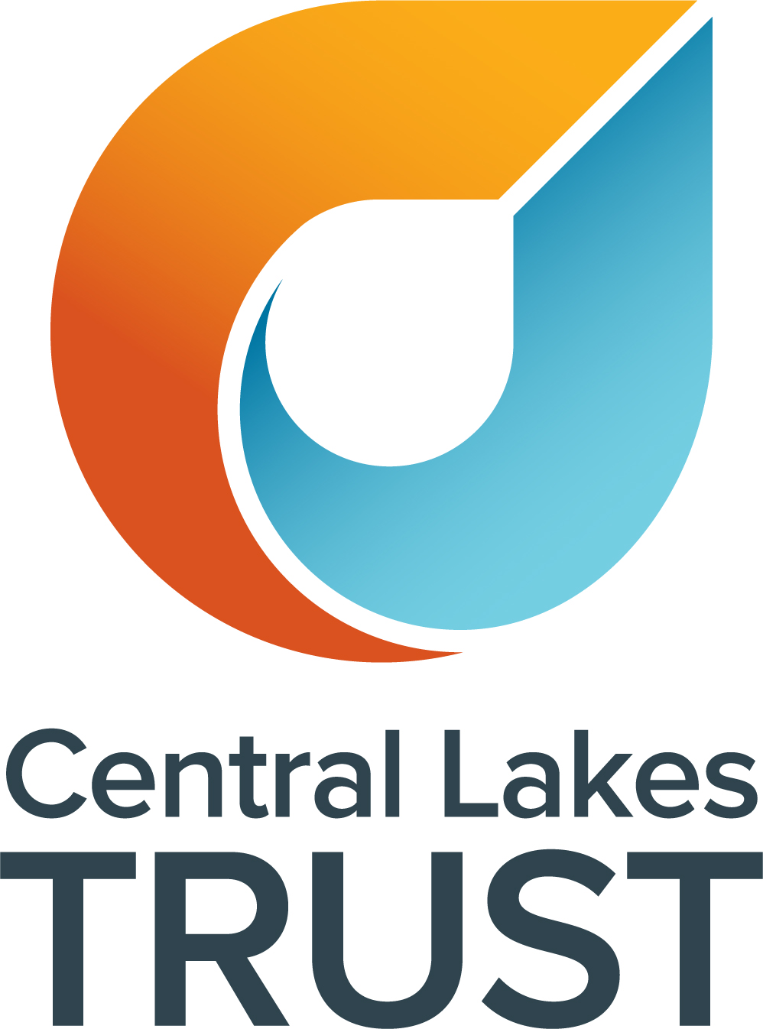
Code of Conduct Policy
Category: | Organisational
Approved by: | Board of Trustees
Policy Effective Date: | 25 November 2019
Responsible Officer: | Chief Executive
Last Review Date | June 2025
Next Review Date: | June 2028 (every three years)

- Purpose
Central Lakes Trust (CLT) trustees and employees shall act at all times with integrity in accordance with CLT’s values.
The purpose of this policy is to assist the board to make decisions that will provide the greatest benefit to the CLT community, ensuring there are clear guidelines and standards for ethical behaviour and professional conduct within CLT.
- Scope
This policy applies to all CLT trustees and employees.
- Principles
The code is based on the following principles of good governance and ethical behaviour:
- Public interest. Trustees and employees should serve the overall interests of the community and should not improperly confer an advantage or disadvantage on any one person, group or locality.
- Honesty and integrity. Trustees and employees should not place themselves in situations where their personal honesty, integrity and good faith may be questioned, or behave improperly and should, on all occasions, avoid the appearance of such behaviour.
- Diligence. fairness and objectivity. Trustees and employees should make decisions on a properly informed basis, with fairness and without bias after a thorough consideration of the pros and cons of each proposal.
- Accountability. Trustees and employees should view themselves as collectively accountable to, and responsible to, the CLT community for their decisions and the manner in which they carry out their role. CLT decisions are not made in public, but the CLT’s decision-making processes should be capable of withstanding scrutiny and reinforce public confidence should the decisions be subject to public review.
- Personal judgement. Trustees and employees should take account of the views of others, but should reach their own, independent conclusions on the matters before them.
- Respect for others. Trustees and employees should promote equitable outcomes by not discriminating against any person and by treating people with respect.
- Positive work environment: Trustees and employees should respect CLT’s impartiality and integrity, and help foster a respectful and inclusive workplace where everyone feels valued and safe.
- Compliance. Trustees and employees should ensure that CLT always acts lawfully and in accordance with its Trust Deed and policies and behaves in a manner consistent with the spirit as well as the letter of the law.
- Policy
This policy defines the behaviours and conduct CLT expects from its trustees and employees, promoting high standards of conduct and practice across CLT and ensuring accountability to the CLT community.
- Standards of behaviour and conduct
Recognising that mutual respect and trust are central to their work at CLT, employees and trustees will, in their dealings with each other and the CLT community:
- Act with impartiality. This includes not doing anything that compromises, or could be seen as compromising, the impartiality of a CLT trustee or employee.
- Be open and honest.
- Demonstrate a positive, constructive and professional attitude, treating others with courtesy and respect. This includes focusing on issues and objectives rather than people and personalities.
- Engage with the CLT community and endeavour to continuosly learn about their needs and aspirations, and how CLT can best support them.
- Be available to the community, as appropriate, including representing CLT at community events and functions.
- Assist potential applicants to contact CLT, assisting in a manner that complements but does not conflict with others’ responsibilities to engage with those groups.
- Participate actively in discussions, sharing their knowledge and point of view openly, as relevant in their roles.
- Seek an understanding of, and demonstrate regard for, the views and opinions of others.
- Maintain public confidence and never acting in a way that could negatively impact on CLT’s reputation and trust within the community, or bring CLT into disrepute.
- Confidentiality
Trustees and employees must not use or disclose confidential information for any purpose other than the purpose for which the information was collected/provided. Matters that should be regarded as confidential include (but are not limited to):
- All information, except any information specifically approved for wider circulation.
- Any emails between trustees and/or employees, unless clearly signalled as available for wider circulation.
- Any personal views as expressed around the board table and/or as part of their role with CLT.
- Collective Responsibility
Once the board has reached a decision, trustees and employees will abide by the principle of collective responsibility and accountability. When speaking externally, trustees and employees (where permitted) will reflect and support the implementation of the agreed position of the board even though their personal views may differ. This includes matters pertaining to investment performance and grant decisions.
- Code of Conduct Breaches
Any behaviour or action which may be in breach of this Code will be given full and impartial consideration. If a breach is identified, further action may be taken in line with the procedures outlined in the Staff Handbook or in the Censure/Removal of Chair, Deputy Chair and Committee Members Procedure, as relevant.
- Relevant Related Legislation & CLT Policies
- Trust Deed
- Governance Charter
- Conflict of Interest Policy
- Staff Handbook
- Censure/Removal of Chair, Deputy Chair and Committee Members Procedure
- Health, Safety and Wellbeing Policy
- Bullying, Harassment and Discrimination Policy
- Protected Disclosures (Whistleblowing) Policy
- Approved

Signature: ______________________________
Linda Robertson, Board Chair

Document Version Control
Version | Date | Description of Changes
1.0 | 25/11/2019 | Policy approved by the board on 25.11.2019
2.0 | 28/06/2022 | Reviewed and updated; approved by the board on 27.06.2022
3.0 | 18/06/2025 | Reviewed and updated; approved by the board on 17.06.2025

